SUMMER NEWSLETTER 2017

Partners

Newsletter

Volume 32, Number 3

Published by:

Guide Dogs of America

13445 Glenoaks Blvd.

Sylmar, CA 91342
(818) 362-5834

FAX: (818) 362-6870

E-MAIL

mail@guidedogsofamerica.org

WEBSITE

www.guidedogsofamerica.org

EDITOR

Lorri Bernson

CONTRIBUTOR

Russell Gittlen

For any comments or questions, please email us at partners@guidedogsofamerica.org.

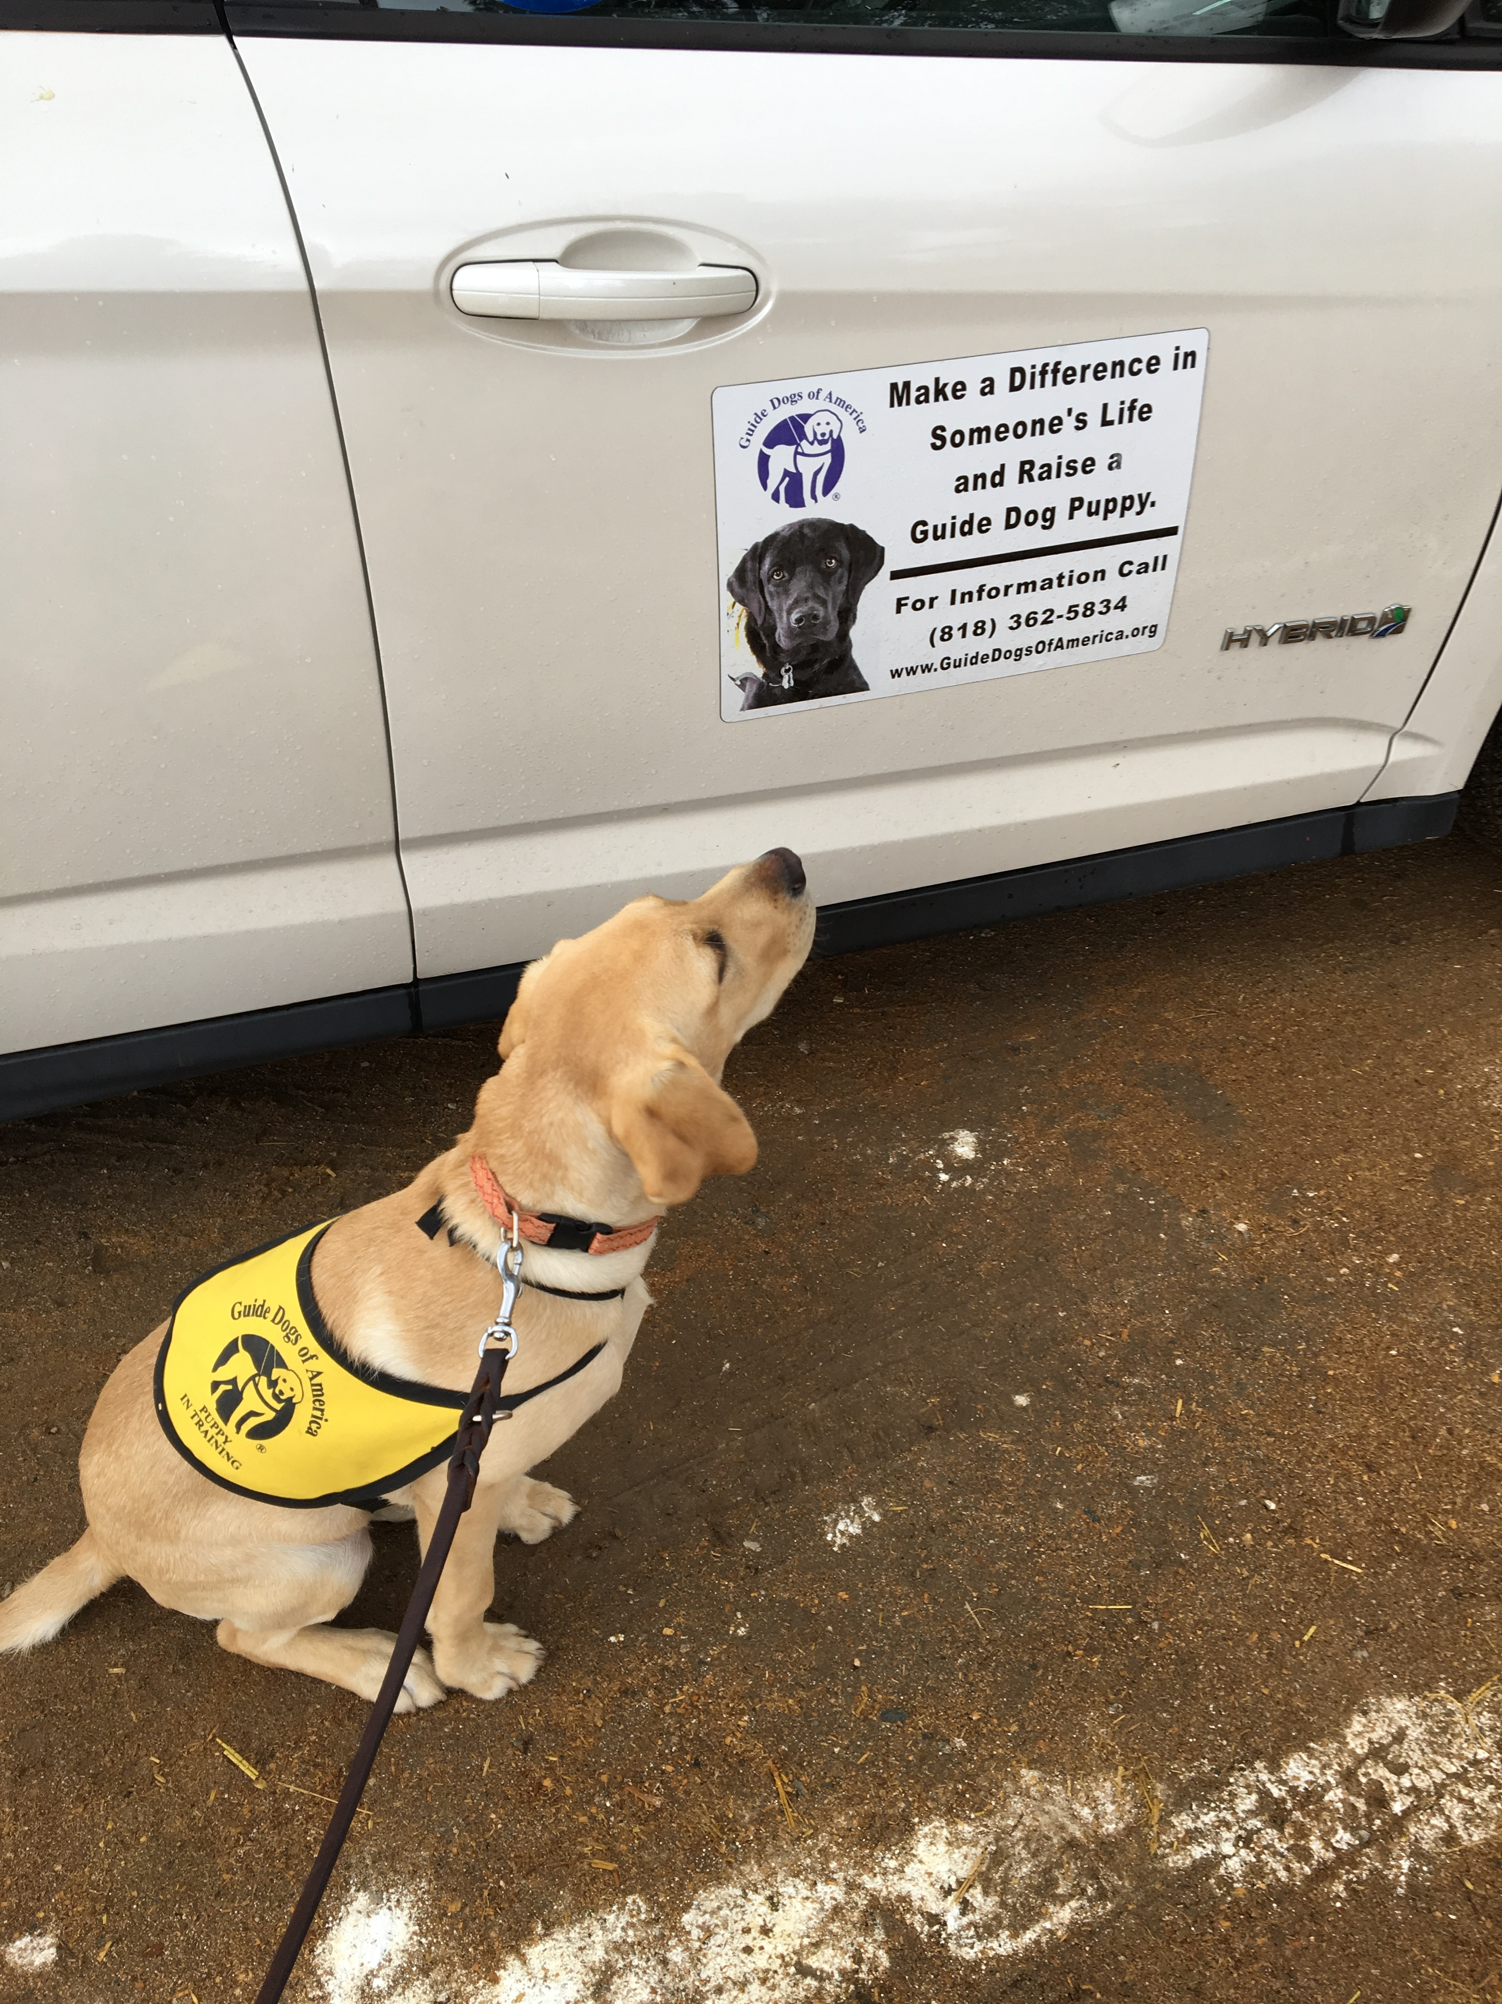
FEATURE

IT’S MORE THAN PUPPY LOVE Why GDA Puppy Raisers Decided to Give of their Hearts and Homes

GDA is extremely fortunate to have and is grateful for our puppy raisers a dedicated group of 200-plus volunteers actively raising puppies at any given time, with many more who have previously raised one or several puppies, while others are waiting to welcome home their first. The question most often asked of puppy raisers is, “How can you give him/her up?”

The answer to that question can be found in the “why.” We asked our puppy raisers to share with us why they decided to raise a GDA puppy. While each person or family has their personal reason, at the core is a desire to help the blind men and women who come to GDA to learn to work with and care for a guide dog and enjoy greater independence and mobility. Several of the many responses and photos are included here.

If, by reading this, you want to learn more about becoming a puppy raiser, we encourage you to visit our website
(www.guidedogsofamerica.org/1/programs/puppy-raising/) to learn more about the program and the areas in which we have puppy raiser groups.

When our son Collin was 15, he told me he wanted to raise a guide dog puppy. We went to a meeting and a puppy raiser, who was about ready to turn in his dog to GDA, came to the front of the room and talked about the experience. The tears welled up a bit in my eyes. I looked over at Collin and he had tears streaming down his cheeks. I leaned over and whispered, ‘We can't do this. We're a mess and it's not even our dog.’ He looked at me and said, "Mom, I know I'll cry when it's our dog but if a blind person gets to go out and have freedom and independence because of the dog I raised, then this is what I want to do." We are currently raising Wellesley, our sixth dog for GDA.
Janice Hart

We did this because we wanted to give back just a bit of the goodness we have had during our lives. It is rewarding to see Cassidy grow and knowing that when I look in her brown eyes they may be someone else's someday.
Alison Schooley

I came across the GDA website and I thought wouldn’t it be wonderful to help a blind person by raising a guide dog. As sighted individuals, we take many things for granted; raising a puppy has made my family and me imagine the challenges a blind person has to go through in daily life. This wonderful four-legged companion can brighten a person’s life by helping them in every way! It also teaches the power of giving for a good cause.
Kiran Ingale

When I was a young teen, I read a novel from 1962 called Light a Single Candle. In it, a 14-year-old girl loses her sight to glaucoma and eventually gets a German Shepherd guide dog. I loved this book, and it lodged the idea of raising a guide dog puppy in my head. Fast forward about 25 years, and I see a GDA van drive by me in Burbank. A lightbulb went off. I went to the GDA website, filled out the application and am now raising Ferris! It’s been a wonderful experience, and my plan is to continue raising puppies for GDA.
Erin Kelly-Park

I first had an interest in working dogs in my 20s. I'm soon to be 65 and I am grateful to be able to work with Guide Dogs of America and volunteer as a puppy raiser.
Debbie Cross

I became a puppy raiser for Jazzy shortly after attending my brother Greg's graduation from GDA with his third GDA guide — Wiki. It was the fourth GDA graduation where one of my brothers was a graduate. My wife Margo said to me after the ceremony, "We should raise a puppy," and we signed up on the spot. We decided that there would be no better way to show our gratitude to GDA for all the wonderful things that Cash, Heidi, Proxy and Wiki have provided David and Greg.
Mike Steinmetz

My husband had a medical issue that caused him to temporarily lose a significant amount of his vision. His vision was restored but he learned, first-hand, what the loss of vision means to a person’s mobility and involvement in social, entertainment and learning activities. He thought at the time that it would be helpful to raise a puppy that might become a guide dog. After attending several graduations and meetings, we decided that we would apply to become puppy raisers and, soon, we became united with our and beloved GDA puppy, Sherlock.
Roberta and Dale Cipra

My husband and I were retired and went to breakfast when a young man came in with a GDA puppy with a little jacket on. I asked him some questions, and he gave me a card from GDA. I had thought about being a puppy raiser for a long time. So, I called GDA, signed up to be a puppy raiser and a few months later got Buddy. Since then, we have raised nine more puppies.
Linda Barber

My husband and I chose to raise a puppy from GDA because we wanted to teach our children to give to others. This is our third puppy and the second with our children. It was one of the greatest lessons of selflessness to give ‘our puppy’ up to be someone else's eyes. This is a lesson that cannot be taught with words. The values our children are learning through puppy raising are invaluable. The bonus is all the puppy love.
Robyn and Will Reinhart
When I first saw a GDA puppy-in-training out in the community my heart leapt! I knew it would be a unique opportunity to combine my love of animals with a chance to model for my young children how to make a difference in someone else's life. They had been begging for a dog, promising to help. ‘We will raise a guide dog puppy and, if you follow through on your promise to help, then afterward we can get a permanent pet dog,’ was my response. After we raised our first GDA puppy, Jubilee, I said to them, ‘OK, you did what you said you'd do and pitched in. Now do you want to get a pet dog or raise another GDA puppy?’ ‘Raise another GDA puppy!’ was the unanimous response that day and each time since, for the next 13 puppies!
Cindy Miller

When I was on spring break from college in 1966, I visited Morristown, N.J., and saw dogs in harnesses being trained, walking around the town. When I retired in 2010, I thought about that visit and decided that raising a puppy might be fun. It was a lot of hard work but the satisfaction of seeing our puppy, Asia, succeed as a guide dog made it all worth it. She is five years old now and has bonded so well with her partner. They are an inspiration to us all.
Rob and Joanna Kim

I became a puppy raiser because I love working with animals and I wanted to give to others… but it has been through giving that I have received so much more, including friendship, inspiration, joy and the ability to make a difference.
Audrey Rohrer
Tracy is the 14th puppy we’ve raised for GDA. We started raising 22 years ago as a way of giving back that was more hands on than simply writing a check. We’ve been addicted to the experience ever since.
David and Mary Brown

We chose to raise a guide dog because we wanted to be hands-on charity. We love the Guide Dogs of America program because it truly changes lives.
Carolyn and John Tyre

I became a puppy raiser almost 30 years ago after I attended a graduation with my Brownie troop. Sixteen little Brownie Girl Scouts looked up at me and asked, ‘Can we raise a puppy?’ It became more than raising a puppy, it became a way of life and, suddenly, we have welcomed the 30th puppy into our home; richer for the family, friendships and love found along the way.
Bob and Pam English

We met a woman at a community event who was raising a GDA puppy. For days following that random meeting, our young daughter begged, begged, begged us to become puppy raisers. What kind of parents could say ‘no’ to their little kid wanting to help the visually impaired, right? Well, years later, we are raising Poe, our fourth GDA puppy-in-training.
Nancy, Mosa, Calvin and Coco Kaleel

When my son was 13 years old, he handed me some paperwork and insisted that I needed to sign it. I asked him what the papers were for and he told me that it was an application to become a puppy raiser for GDA. I asked him why he wanted to be a puppy raiser. He told me, ‘I've thought about this a lot and decided that we take and take all of our lives. I want to do something to give something back to someone else.’ How can you say no to that? Our first puppy came to us shortly afterward, and we are now raising our 10th puppy, Colt.
Karen Warloe

I chose to become a GDA puppy raiser because I could be a part of something so wonderful. Attending a graduation ceremony; hearing about the process and witnessing the love, support and life-changing experience for all involved helped solidify this decision. I am currently raising my fifth dog and let me say that it has been an incredibly rewarding experience.
Sharon Sega

Growing up, my best friend's family raised puppies for GDA, and I knew it was something I wanted to do someday. Fast forward 10-plus years and here I am! I'm so happy to finally be pursuing this dream of mine.
Kaity Taylor

VET’S CORNER

STOP AND SMELL THE ROSES, BUT AVOID THESE FLOWERS AND PLANTS

Summer is here, and it’s time to take in the great outdoors. Whether in your own city or neighborhood or enjoying a vacation away from home, there are plants and flowers that can cut the fun short.

“As a general rule, most beautiful blooms have adverse effects in dogs. Issues range from gastrointestinal signs including vomiting and diarrhea, to neurologic and cardiac signs such as a stumbling, seizures and heart rhythm abnormalities,” said GDA Veterinarian Ainjil Bills. “For example, both azaleas and oleanders can cause heart failure.

Here is a list of just some of the common flora and fauna that can lead to health problems in dogs. Many are common sense — poison ivy and cactus — but there are others that may come as a surprise such as hydrangea and agapanthus.

Note that this is only a partial list that focuses on plants and flowers that have a summer season.

“Sago palm is not a summer bloom, but due to its extreme toxicity it is important that dog owners are aware of the danger it poses. When ingested, this palm can cause severe liver damage, even liver failure,” said Bills.

Always contact your vet if you think your dog has ingested or come in contact with the plants listed here or with something that you are unsure of. Your vet will be able to determine if the animal needs to be seen and treated or what kind of first aid should be administered.

UPSET STOMACH Agapanthus — all parts

Amaryllis — bulb

Cala Lily — all parts

Carnation — all parts

Chrysanthemums - all Parts

Gladiolas - leaves

Hydrangea — all parts

Morning Glory — seeds and Leaves

Peony — leaves, stems, roots

RASHES

Cactus — leaves and spines

Poison Ivy — all parts

Poison Oak — all parts

Primrose — leaves

ORGAN DAMAGE

Azalea — all parts

Baby’s Breath — flowers and stems

Cardboard Palm — all parts

Crocus — all parts

Foxglove — leaves, stems, roots

Juniper — berries and leaves

Lantana — all parts

DONOR PROFILE
Bill and Pam McDonald Giving Their All to GDA

For GDA Partners in Trust Bill and Pam McDonald, it took only one visit to GDA to know they wanted to offer their financial support to the school.

“We attended Open House, and it just hit me. Watching the guide dog demos and the puppies-in-training and starting up conversations with students and hearing how having a guide dog has changed their life,” Pam McDonald said. “I had a lump in my throat and a tear in my eye the whole time I was there. I was so touched.”

The couple became donors in 1996 and in 2008 they became Partners in Trust.

“Everything is going to GDA. The entire estate,” Pam McDonald said. “What better way to have our estate live on? Our gift will help the school continue its work with these beautiful animals and to make such a difference in the lives of those who receive them. I feel really peaceful about our choice.”

Several years ago, after they had already been donating to GDA, Pam McDonald had a serious staph infection in her eye, which left her unable to see for several months. Fortunately, the ophthalmologist was able to save her cornea, but the experience gave her a deeper understanding of how difficult it is to be independent when you cannot see.

“It really helped me understand what not having a guide dog would mean to someone with a vision loss,” she said. “Not only in how the dog helps you move through the world, but the companionship they provide. If I didn’t have my personal dogs during that period, I would have gone crazy.”

McDonald has introduced several of her friends to GDA by bringing them to Open Houses, and many have donated after their visit.

“I think if someone experiences GDA the way I did the first time, they will understand what a difference their contribution will make. A guide dog gives a blind person’s life back to them,” Pam McDonald said. “GDA is a legitimate charity, and I am so happy that our support of the organization will continue through our estate. I cannot think of a better cause and I don’t think there is any better group than Guide Dogs of America.”

For information about becoming a Partner in Trust, please contact Rhonda Bissell at (818) 833-6432.

IN MEMORY
It is with sadness that we mark the passing of the following graduates:
Don Bishop — Class 326
Sharon Conkling — In home
Christine Diller — Class 356
Roy Novotny —In home

We also note with sadness, the passing of the following guide dogs, breeders and stud dog:
Capri — Class 352
Gareth — Class 373
Kayla — Class 356
Nathan — Class 354
Onna — Class 353
Paisley — Stud
Sawyer — Breeder
Scylla — Class 359
Verrina — Breeder

NEW EMPLOYEES
Hanna Belyea — Canine Development Assistant
Kelsey Horst — Apprentice Trainer

2017 QUILT RAFFLE

This year’s make-you-smile quilt, “Happy Dogs Brighten Lives,” was handmade and donated by the Santa Clarita Valley Quilters Guild. Every square features a unique design, and a special square on the back includes the quilters’ signatures. The quilt measures 94” x 100”.

Purchase tickets using the order form on this page and mail it to GDA postmarked by Dec. 1, 2017 or call GDA at (818) 833-6429. Tickets are $2 each or six for $10. Drawing to be held at the GDA December puppy raiser holiday party. Winner does not need to be present.

SUMMER MERCHANDISE

Merchandise can be purchased on our website (www.guidedogsofamerica.org) and clicking on “Shop GDA”, at the new GDA gift shop or by calling (818) 833-6429.

7th-ANNUAL HOLIDAY CARD
GDA 2016 Holiday Photo Card Contest Winner!

Congratulations to Guide Dogs of America volunteer puppy raiser Lexie Dreyfuss. Her photo of GDA puppy-in-training Venti will be the cover of GDA’s annual holiday card. We received so many great photos. Thank you to all who sent in submissions and thank you to all who voted!

The card’s inside message: ““Pawsing to wish you Happy Holidays”

Holiday cards measure 5” x 7” and are bundled 15 cards (with envelopes) to a pack. Price: $18 plus tax per pack. Price includes shipping and handling.

Limited-Edition Custom GDA Bracelet
Keep GDA with you all the time with our Limited-Edition Expandable Bracelet. The charm that adorns this gold expandable bangle has the GDA logo on it, along with the year 2017 directly under it. There is only a limited amount available, so order soon! (Think "holiday gifts" early!) Includes a hand-made, drawstring gift bag with purchase. Made in U.S.A. Price: $33 plus tax. Price includes shipping and handling.

2017 GDA Lapel Pin [PHOTO]
This year’s pin features the Guide Dogs of America logo. The words “Guide Dogs of America” appear above the logo and the year 2017 is below. The pin also features a vibrant green leaf wreath border. Made in the U.S.A., the gold metal pin is 3/4” round. Price: $8. Price includes shipping and handling.

SAVE THE DATE

GDA Las Vegas Charity Event — Nov. 16-18

Mark your calendars for the annual Las Vegas Charity weekend Nov. 16-18. The weekend will kick-off on Thursday, Nov. 16, with the Hawgs for Dogs ride and the sporting clay event. Friday morning, foursomes will tee off at Angel Park Golf. The weekend will conclude on Saturday evening with the 37th-annual William W. Winpisinger Charity Banquet at The Paris Las Vegas Hotel & Casino. Invitations will be mailed early this summer, and details posted on the GDA website.

SAVE THE DATE
GDA Open House Returns!

Please join us for Open House on Saturday, Oct. 7. This fun-filled day includes puppy trials, guide dog demos, puppy kissing booth, tours, merchandise, Kids' Korner, delicious food, and the ever-popular Silent Auction featuring hundreds of beautiful gift baskets and single items.

Admission to the Open House is free. There is food available for purchase. Gates open at 10:45 a.m. and close at 4 p.m. Events begin at 11 a.m. and end at around 3 p.m. We do ask that you leave your personal pets at home.

NEW VISITOR AND EDUCATION CENTER NAMING OPPORTUNITIES
Several naming opportunities are still available for areas of the new Macki and Phil Singer Visitor and Education Center building. Learn more about how your donation can support this exciting new addition to the GDA campus by visiting our website at guidedogsofamerica.org or contact Rhonda Bissell at (818) 833-6432.

Naming opportunities include:
GDA Store — $10,000 (NAMED)
Audio/Visual Display 1 — $10,000 (NAMED)
Audio/Visual Display 2 — $10,000
GDA History Wall — $15,000 (NAMED)
Break Room - $25,000 Serving Room $25,000
Flag Pole — $25,000 (NAMED)
Board Room — $50,000 (NAMED)
Courtyard — $100,000 (NAMED)
Apartment — $100,000
Lobby — $150,000
Large Meeting Space — $250,000 (NAMED)

PARTNERS IN TRUST

Make your gift to Guide Dogs of America last a lifetime and beyond. The Partners in Trust Society was established by GDA as a way to recognize and honor the generosity of those who have included the school in their planned giving. Providing life income gifts and bequests lets your gift continue working beyond your lifetime to help others achieve their goals with increased mobility and independence through a partnership with a loyal and loving guide dog. Charitable organizations are not subject to gift or estate taxes so your gift continues to support the causes close to your heart, like Guide Dogs of America, without being diminished by the IRS.

You will receive our special “Partners In Trust” crystal jar as a way of thanking you that you can display proudly, knowing the difference you are making in the lives of others through supporting Guide Dogs of America. Please call Rhonda Bissell at (818) 833-6432 for more information.

GDA MISSION STATEMENT

Guide Dogs of America is dedicated to its mission to provide guide dogs and instruction in their use, free of charge to blind and visually impaired men and women from the United States and Canada so that they may continue to pursue their goals with increased mobility and independence.

