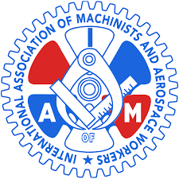

Boston IAM Local 1726
4th Annual Charity Bowling Event to benefit Guide Dogs of America
“PINS FOR PUPS”

Tuesday June 4, 2019 3:00 p.m.-7:00p.m.
Town Line Luxury Lanes
Malden, Ma

2 Hours Bowling & 2 Hours After Party
Food, Cash bar & Raffle Drawings
Registration $35.00 pp - Event T-shirt $25.00
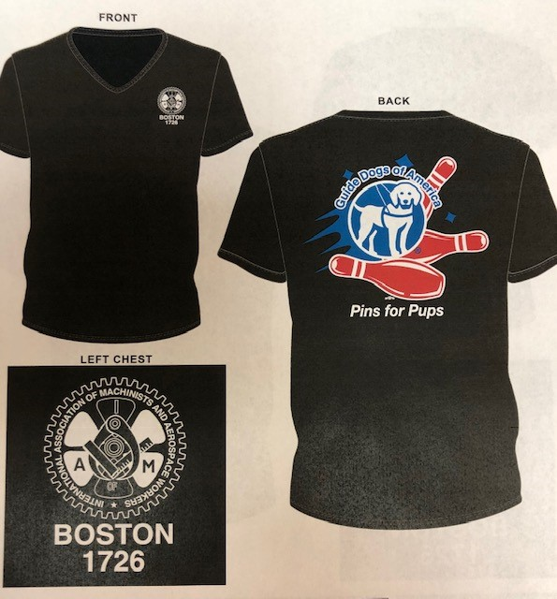

**Promotional offer
Early paid registration by March 15,2019
$ 50.00 pp includes Event T-shirt
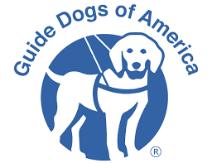
Checks Payable to Guide Dogs of America Contact info: 617-569-0141 Local1726communityservice@gmail.com

