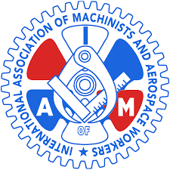

IAMAW Local 1726 Boston
5th Annual Charity Bowling Event
to benefit Guide Dogs of America
“PINS FOR PUPS”
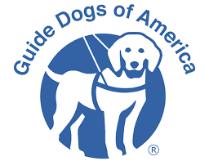

Monday, April 6,2020 3:00 p.m.-7:00p.m.
Town Line Luxury Lanes Malden, Ma

2 Hours Bowling & 2 Hours After Party
Featuring the Queen of Boston Comedy
Christine Hurley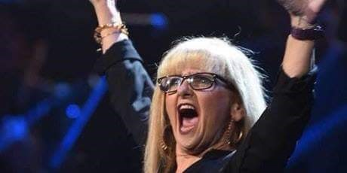
Food, Cash bar & Raffle Drawings
Pre -Registration required
$40.00 per person* non refundable

Checks Payable to Guide Dogs of America
For more information or registration forms contact-
617-569-0141 or Email: Local1726communityservice@gmail.com

