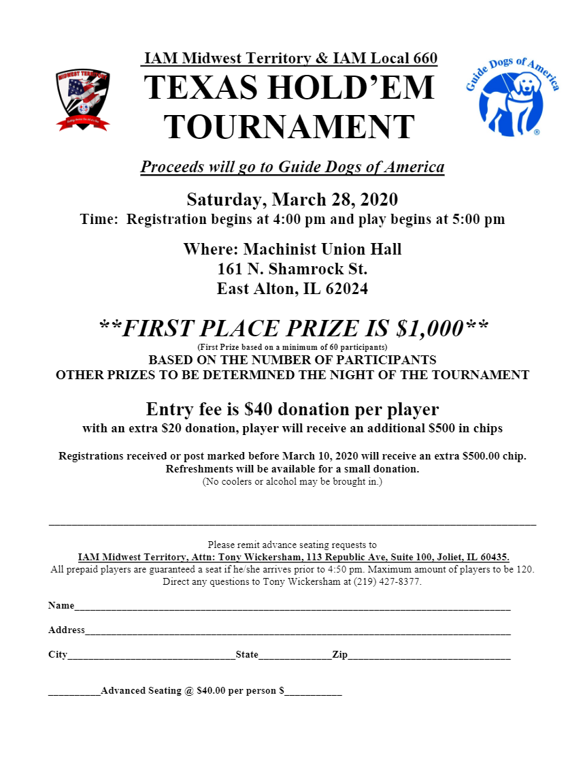

NEW DATE: Saturday, May 30, 2020