You are invited to a Charity Golf Tournament to benefit the
Guide Dogs of America

Dear Business Owner, Friends and Sponsors,
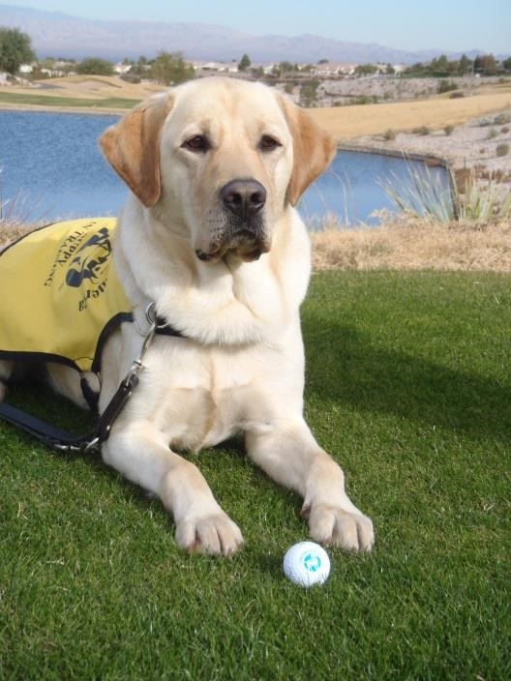
As a valued prior participant, we would like to thank you and invite you to next year’s third (3rd) Annual Charity Golf Tournament to be held on June 5, 2020 has been rescheduled to August 21, 2020 at the Spring Meadows Golf Club in Gray, Maine.
For new participants we would like to invite you to take part in this charitable event as well.
The event is being held to benefit the Guide Dogs of America, an organization that provides seeing eye dogs to individuals at no charge, founded by the I.A.M.A.W. in 1947. There is additional information about the organization on their website www.guidedogsofamerica.org . It is by your generous gifts, contributions and participation that we raise funds to insure GDA continues to help the sight impaired. Various opportunities to help exist, hole sponsorships of Silver-$400, Gold-$700 or Platinum-$1,300 are available. These sponsorships will get your business sign prominently displayed at one of the 18 holes and the platinum sponsorship includes a foursome of golf. Alternately you could sponsor a team from your Organization of four golfers for $500. A team sponsorship includes the four rounds of golf, a cart and a lobster /steak dinner.
Lastly, we are asking for the donation of prizes that can be raffled off at the event, or any cash donation is appreciated. Your participation in this event can help change lives, please consider helping in any way you can and call with any questions 207-407-1222. Thank you for your continued generosity.
Sincerely,
The Staff and Officers of DL4

Registration/Donation Form

Organization Name: ______________________________________________
Contact: ________________________ Number: ________________________

We will donate a prize for the raffle: __________________________________
(example: business gift card, product, etc.)

We Would Like to Be a hole Sponsor;
Silver $400
Gold $700
Platinum $1300

We would Like to sponsor a team (you will be provided with additional details)
Golfer 1 _______________________
Golfer 2_______________________
Golfer 3_______________________
Golfer 4_______________________

We cannot attend or do not play golf but would like to
make a contribution to Guide Dogs of America
$_______________________________
Please make checks payable to Guide Dogs of America- Your gift is tax deductible to the extent provided by law. Mail To: IAM DL4 Attn: George Edwards, 698 Lisbon St, Lisbon Falls, Me 04252

